CST1510 — Multi-Domain Intelligence Platform
Coursework 2 — Technical Report

Student Name | ROPAFADZO CHIDIYA
Student ID | M01060562
Programme | BSc Cyber Security and Digital Forensics
Module | CST1510 — Multi-Domain Intelligence Platform
Academic Year | 2025/26
GitHub Repository | Roro290506/CW2_CST1510_M01060562: Final Project for module CST1510

Table of Contents
1. Introduction
2. System Architecture & Design
2.1 Security — Password Hashing & Authentication
2.2 Database Design & CRUD Operations
2.3 Application Architecture
2.4 Web Interface — Streamlit
2.5 AI Integration
3. Key Features & Implementation
3.1 User Authentication System
3.2 Cybersecurity Domain Dashboard
3.3 Data Science Domain Dashboard
3.4 IT Operations Domain Dashboard
3.5 AI Assistant
4. Testing & Validation
5. Reflection & Conclusion
5.1 What I Learned
5.2 Challenges Faced
5.3 Future Improvements
5.4 Conclusion
6. References

1. Introduction
✎ Suggested word count: 150–500 words
(Guidance: Write 2–3 paragraphs. Paragraph 1: what the platform is and who it is for. Paragraph 2: what problems it solves. Paragraph 3: how this report is structured.)
This is digital forensics and operational intelligence platform serves as a centralized dashboard designed for IT administrators, external auditors and law enforcement agencies such as Interpol. To monitor and analyze critical organizational data. By aggregating disparate information into three primary categories cyber incidents, IT tickets and dataset metadata. The platform provides a clear view of the organization’s digital landscape. It tracks the lifecycle of cyber threats including severity levels and resolution status while simultaneously monitoring IT tickets to track priority levels and resolution progress. Furthermore, it generates metadata regarding various departments tracking record density and the categorical distribution within each department.
The platform addresses significant architectural and analytical limitations inherent in legacy on-premises systems which often restrict data access to local personnel and create information silos. By migrating these datasets to a secure, remotely accessible environment the platform enables real-time situational awareness and cross-departmental collaboration. This shift not only democratizes access to security intelligence but also empowers stakeholders to move beyond reactive troubleshooting. Through the systematic analysis of incident trends and metadata, users can derive actionable insights, strengthen their defensive posture, and proactively mitigate risks before they escalate.
This report is structured to detail the platform's core features and their specific functionalities, demonstrating how each component contributes to effective cybersecurity and operational management and finally give conclusion if it met all the prerequisites.

2. System Architecture & Design
✎ Suggested word count: 400–700 words

2.1 Security — Password Hashing & Authentication
(Guidance: Explain bcrypt: what it is, why it is used instead of MD5/SHA-256, what salting does, and how checkpw() works. Reference the generate_hash() and is_valid_hash() functions in your code.]
Bcrypt is a highly specialized robust password-hashing algorithm designed to protect user credentials through three foundational pillars: intentional computational slowness, an adaptive cost factor and the application of cryptographic salting. Unlike standard hashing algorithms such as MD5 or SHA-256 which were originally engineered for high-speed data integrity, file verification, and rapid performance bcrypt is purposefully designed to be intentionally slow. This performance overhead serves as a vital security defence mechanism because standard hashes are too efficient, they allow attackers to perform millions of potential password guesses per second during brute-force or dictionary attacks. By contrast bcrypt introduces a deliberate computationally expensive delay that makes such high speed attacks physically and computationally infeasible. This is further strengthened by its adaptive cost factor, which allows the algorithm to remain resistant to modern hardware advances by enabling developers to increase the work factor as processors become faster ensuring the time required to hash a password remains a persistent barrier to intruders.
A critical component of this security architecture is salting, which involves generating a unique, random string of bits for every single password before the hashing process occurs. This practice acts as the primary defence against rainbow table attacks where attackers use precomputed lists of hashes to reverse-engineer passwords. By utilizing bcrypt.gensalt(rounds=10) we ensure that even if two users choose the same password their final stored hashes will be completely distinct and unpredictable. While higher round counts increase security by making the hashing process even more resource intensive it is essential to calibrate these rounds carefully as an excessive cost factor can introduce significant latency and negatively impact the overall responsiveness of a system.
In my own Python implementation, the generate_hash() function handles this end-to-end workflow: it first invokes the gensalt(rounds=10) method to create a unique salt, then passes that salt along with the plaintext password into bcrypt.hashpw() to produce a highly secure salted hash ready for storage. When it is time to authenticate a user during a login attempt, the is_valid_hash() function acts as the gatekeeper by utilizing bcrypt.checkpw(). This powerful function takes the incoming plaintext password and the previously stored, salted hash as parameters. Internally bcrypt.checkpw() performs a sophisticated verification process it extracts the original salt that was embedded within the stored hash. Uses that specific salt to re-hash the newly provided password input and then performs a secure constant-time comparison to determine if the resulting hash matches the one on file. This verification method ensures the system can confirm the user’s identity without ever needing to store or expose the raw password itself. I also implemented password validation using regex to ensure it has 8 characters inclusive of 1 lowercase letter,1 uppercase letter,1 special character and 1 digit.

2.2 Database Design & CRUD Operations
[Guidance: Describe your SQLite database: the 4 tables, their columns, and key constraints. Include the schema as a table or code block. Explain why you used parameterised queries and what SQL injection is.]

Table | Purpose | Key Columns
users | Stores registered user accounts | id (PK),email, username (UNIQUE), password_hash, role
cyber_incidents | 115 cybersecurity incident records | incident_id, timestamp, severity, category, status, description
datasets_metadata | Registry of analytical datasets | dataset_id, name, source, size, last_updated
it_tickets | 150 IT support ticket records | ticket_id, priority, category, status, resolution_time
ai_prompt | Stores the ai prompts made by the user, LLM response and LLM response time | prompt_id(PK), user_id(FK), time, prompt, response, response time
logs | Stores the platforms log history | log_id(PK), user_id(FK), login_time, logout_time
password_reset | Stores currently active password reset tokens | Id(PK), email(FK), token, time_created, expires_at
SQL Injection is a critical vulnerability that occurs when malicious input is concatenated directly into SQL commands allowing attackers to manipulate database logic and unauthorizedly access or modify data. I used parameterized queries as a defense because they strictly separate code from user-provided data. By treating input as literal values rather than executable commands the database engine ignores any malicious SQL syntax within the input effectively neutralizing the risk of injection and ensuring the structural integrity of every query.

2.3 Application Architecture
[Guidance: Describe the modular structure of your codebase. Explain the app_model/ package and why you separated concerns into individual files. Include an architecture diagram or a folder tree.]
The modular structure of my application follows a refined Model-View-Controller (MVC) architecture designed to enhance maintainability and separate concerns by decoupling logic from the user interface. My architecture is organized into three primary layers each with distinct responsibilities. The Model located in the app_model acts as the backend engine, centralizing all data-handling and business logic. This layer interacts directly with the database to execute schema creation, manage record insertion, and house validation functions. Additionally I have integrated a logic folder within the model to handle data fetching for display specifically for my analytics pages such as cyber incidents, IT tickets, logs, metadata and AI prompts.
The View and Controller layers are handled by the pages directory and Home.py, which provide the graphical user interface where users interact with the application, input information, and visualize datasets. As the Controller these pages orchestrate the flow of information by capturing user inputs and invoking the necessary backend functions within the app_model to process data or update the database. By isolating code into specialized files, such as db.py for database operations, hashing.py for security, and users.py for business logic I ensure that specific tasks are contained in their own modules. This separation of concerns allows for cleaner code, easier debugging, and improved scalability as my project grows.
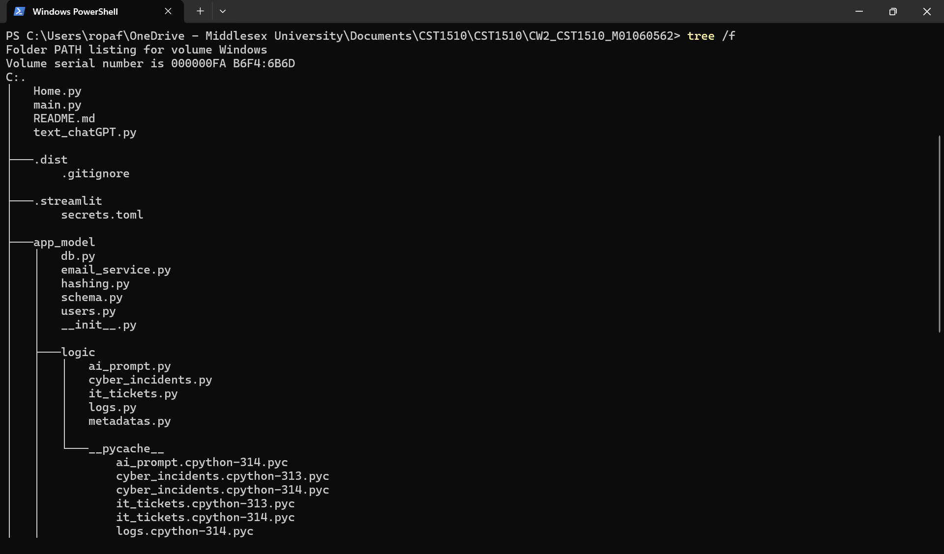
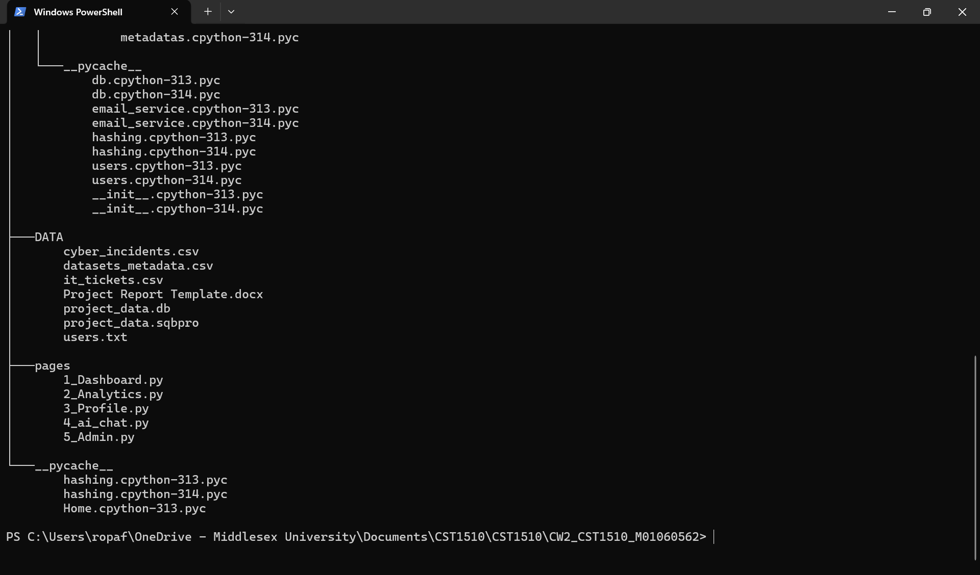

2.4 Web Interface — Streamlit
[Guidance: Explain what Streamlit is and why it was chosen. Describe the multi-page structure, session state, and how page protection works.]
Streamlit is an open-source Python library designed for creating interactive web platforms focused on data visualization and user engagement. It was specifically selected for this project because it allows developers to build web interfaces without requiring prior expertise in HTML or CSS, significantly lowering the barrier to entry and simplifying the development workflow.
My platform utilizes a multi-page structure unified by a primary entry point, Home.py which enables seamless navigation between different sections in the pages folder that appear on side bar and using the “st.switch_page” function. To maintain state across these interactions my platform leverages st.session_state a temporary memory location that stores user-specific data for the duration of a session and automatically clears it once the session concludes. Streamlit also supports performance optimization through features like st.cache_data (e.g st.cache_data(ttl=600)), which pre-stores data after the initial load to minimize repetitive database fetches. Which l implemented before all the database fetching function eg get_all_cyber_incidents as it stores the cached data for 10 minutes which is the 600s of the time to live.
Page protection and access control are implemented using these session state mechanisms to ensure application security. For instance my system validates the "logged in" state. If a user is not authenticated access is restricted to the login-ready Home.py page only. Furthermore the architecture supports role-based access control by storing user roles within st.session_state["role"], ensuring that sensitive areas such as the admin page are visible only to authorized users. Security is further strengthened through the use of secrets.toml to protect sensitive information like API keys and email credentials for my sender email while the st.query_params feature allows for secure processes like password resets by reading tokens directly from URL links in my website.

2.5 AI Integration
[Guidance: Explain the OpenAI Chat Completions API: the messages list structure, the three roles (system/user/assistant), conversation history, and streaming. Describe the domain-specific system prompts you wrote.]
My platform utilizes the OpenAI Chat Completions API standard via Groq to deliver a secure, domain-specific AI assistant structured around a persistent st.messages list that maintains conversation context while ensuring data isolation between individual user sessions. The interaction flow is defined by three distinct roles. The System role which establishes the model's identity as an expert in cybersecurity, IT operations, and data science while enforcing a read-only SQL generation protocol. The User role which provides the input prompts. The Assistant role which appends the final response into the st.messages list. To improve the user experience my platform utilizes streaming and a cursor effect to simulate real-time thinking. While simultaneously employing an administrative audit table to track prompts, responses and latency. This audit mechanism is critical for both security by monitoring for prompt injection or attempts to compromise platform integrity and performance optimization ensuring the LLM consistently meets the required operational standards for my technical infrastructure.

3. Key Features & Implementation
✎ Suggested word count: 300–600 words
[Guidance: For each feature: describe what it does, include a screenshot of the working feature in your application, and briefly explain the key code or design decision behind it.]
I implemented a secure “Forgot Password” feature to help users regain account access. The process generates a cryptographically strong URL-safe token using secrets.token_urlsafe(16). This token is sent to the user via email using the smtplib library. Upon clicking the link st.query_params retrieves the token from the URL to authenticate the request and render the password reset interface. To maximize security my system enforces a 15-minute token expiration period after which it is automatically deleted. Finally the feature uses standard password hashing and database update functions to ensure the new credentials are stored securely.
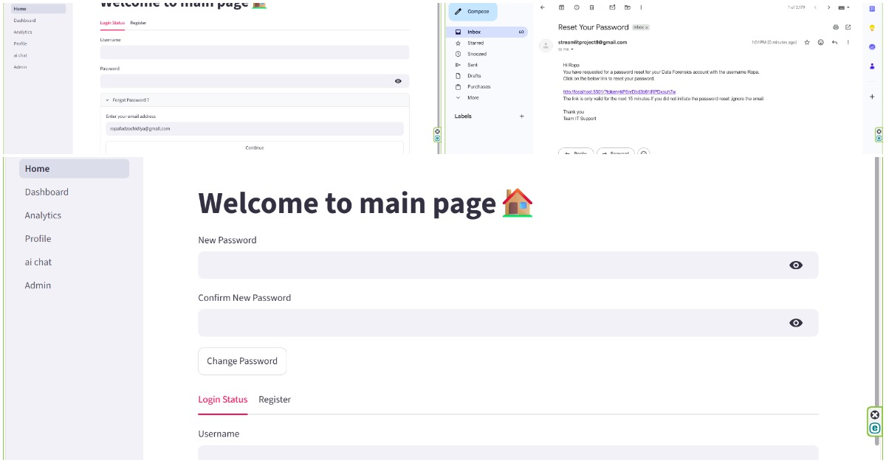
To manage the dashboard's interface efficiently I implemented a centralized view system using st.session_state. Instead of creating separate pages for different data categories I used st.session_state["selected"] to store the user's current preference. A controller function (dataset_choice) monitors this state variable and automatically updates the main workspace to display specific data such as Cyber Incidents, IT Tickets , Metadata or All that the user has requested. This design decision ensures a clean clutter-free navigation experience and allows the application to feel like a responsive single-page interface through st.switch_pages to the Analytics page that houses all functions.
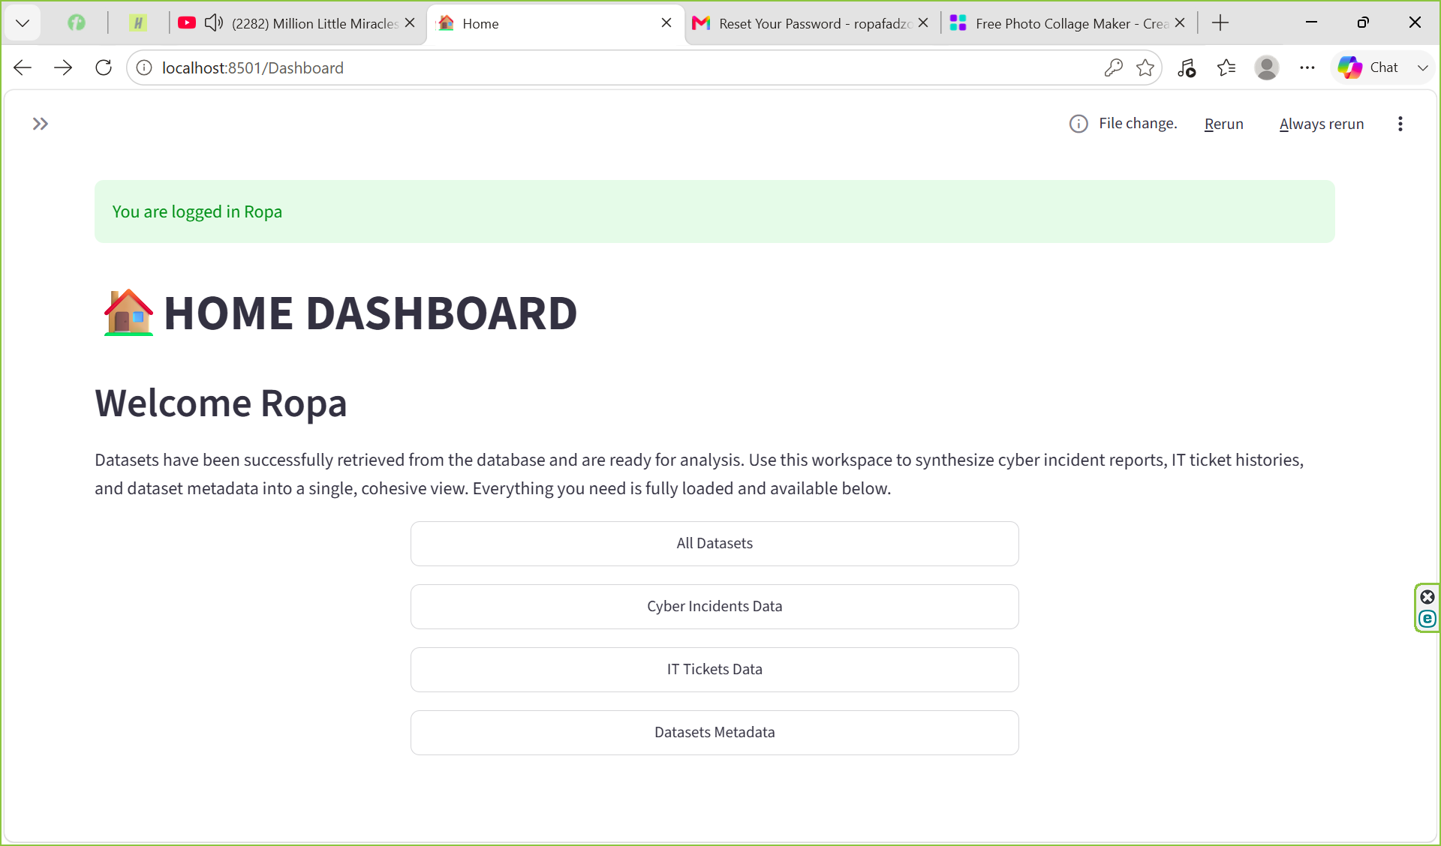
I added an administrative view to track user registration counts,ai prompts and user logs.Which is protected by role-based access control (RBAC). Admin status hardcoded in the database rather than through shared credentials this mitigates risks like credential stuffing and unauthorized access common with generic accounts. Authorization is enforced in the UI by verifying that st.session_state["logged_in"] is true and that the st.session_state["role"] matches the "admin" requirement.
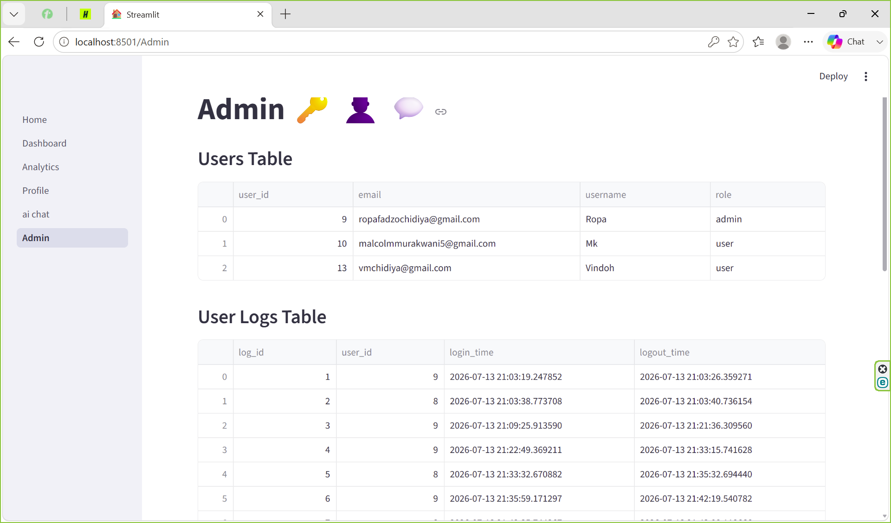

3.1 User Authentication System
[Guidance: Screenshot: login form + successful login. Describe the full login flow: form → bcrypt verification → session state → redirect.]
[Insert screenshot of your login page here]
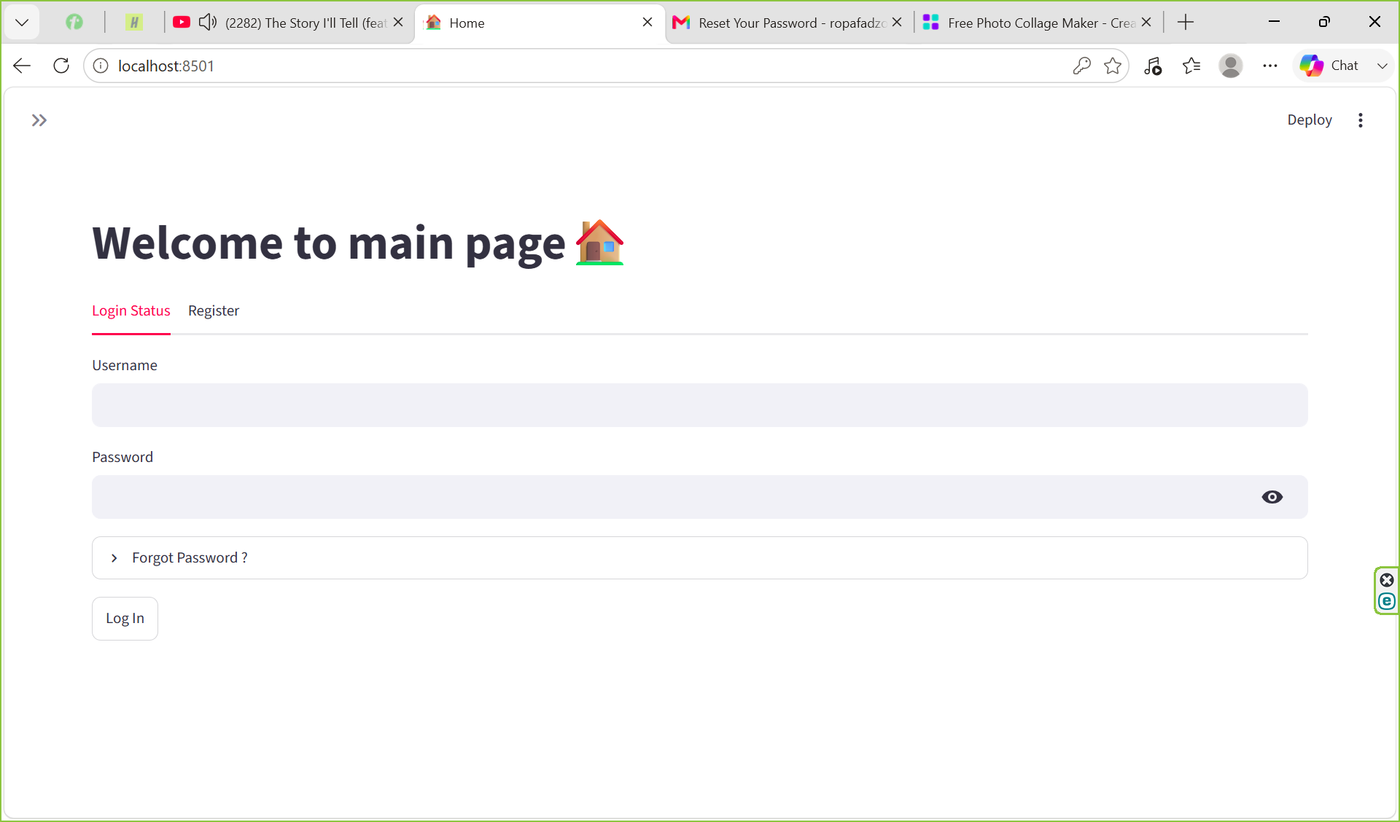
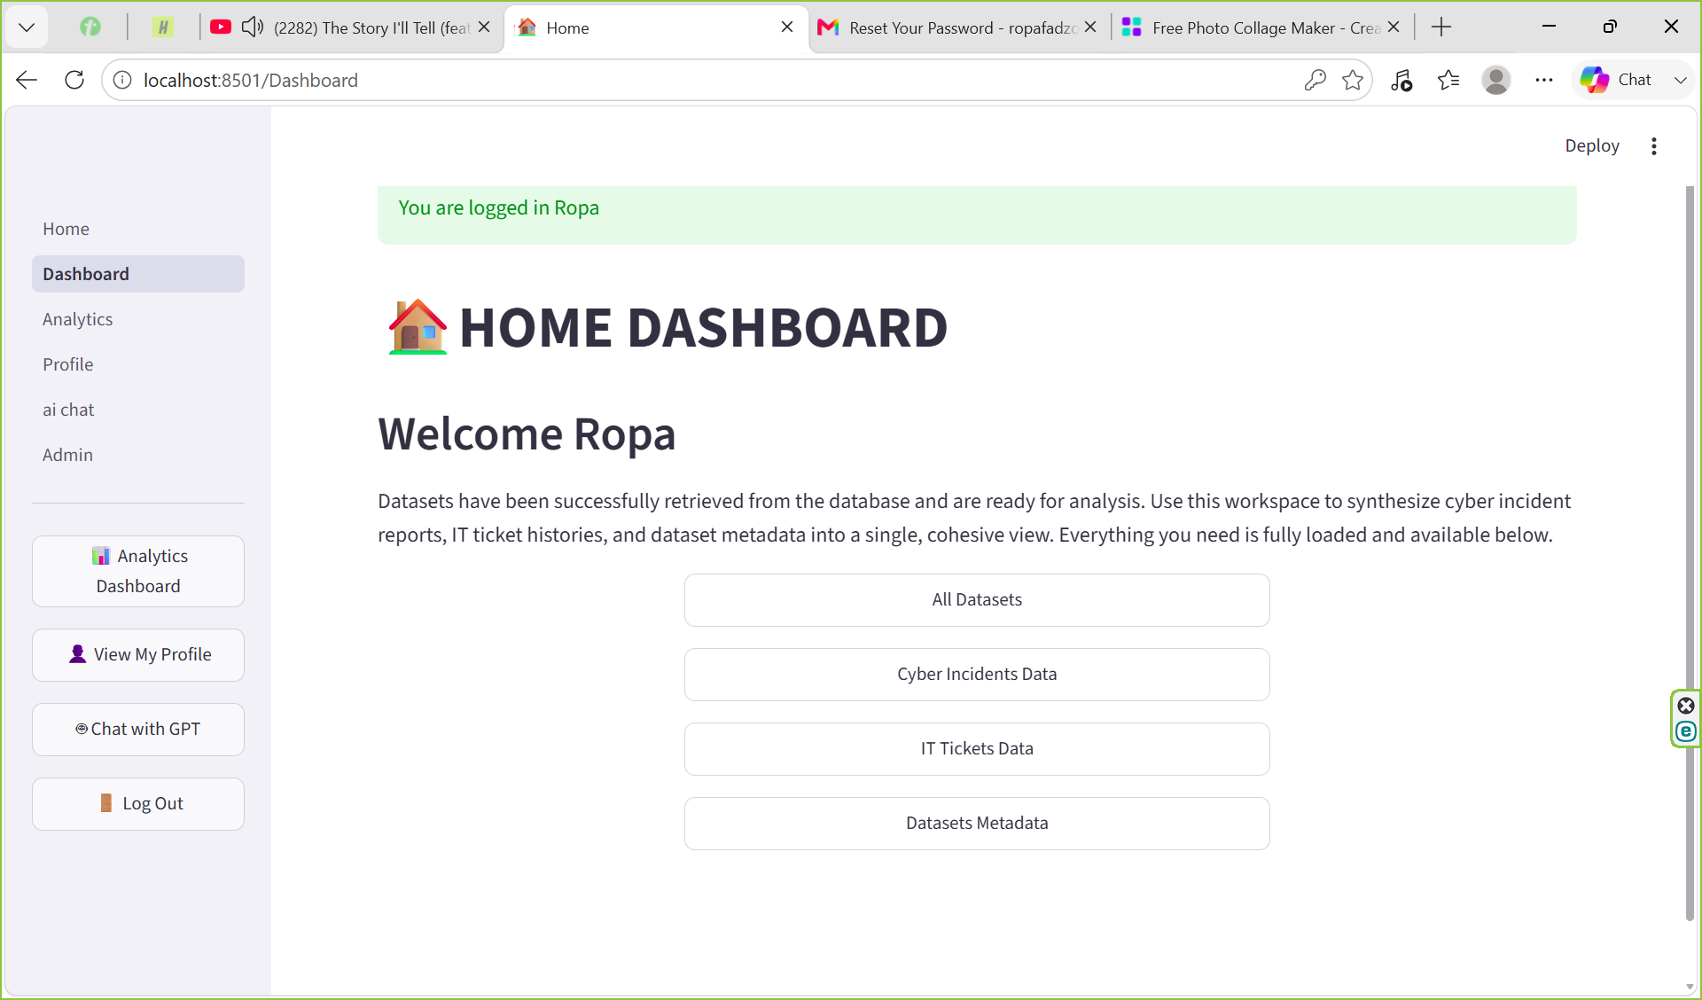
The user authentication system provides a secure entry point to the applicationbeginning with a login form that verifies credentials against the database. Once the username is confirmed the system retrieves the stored password hash and utilizes the bcrypt library's checkpw function to securely compare the entered password against the stored value. Upon a successful match the application updates st.session_state["logged_in"] to True. Which programmatically triggers a redirect from the login page to the Home Dashboard ensuring a seamless and secure transition for the user through the use of st.switch_pages.

3.2 Cybersecurity Domain Dashboard
[Guidance: Screenshot: incidents table + chart. Describe what data is shown, how it was loaded, and what insights the visualisation provides.]
[Insert screenshot of your Cybersecurity dashboard here]
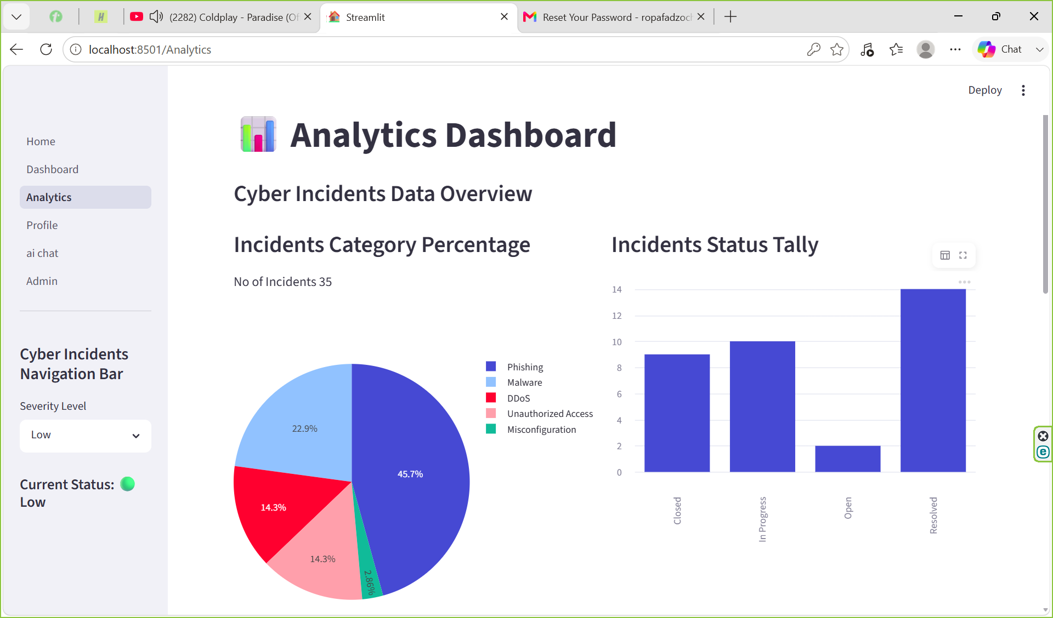
The analytics dashboard visualizes cybersecurity data by filtering incidents based on their severity level and representing category distribution through a dynamic pie chart and bar chart. This data is efficiently loaded from the cyber_incident table in the database using the get_all_cyber_incidents function imported from app_model.logic which loads it into a dataframe.Then the data is displayed if the user preference is to see the cyberincidents. For instance, the chart illustrates that phishing incidents account for the highest share of low-severity cases at 45.7%. and the pie chart is rendered using the plotly library for clear data representation. The dashboard includes an incident status tall, which is generated using the st.bar_chart function to provide a concise overview of the current status of various security incidents value count.
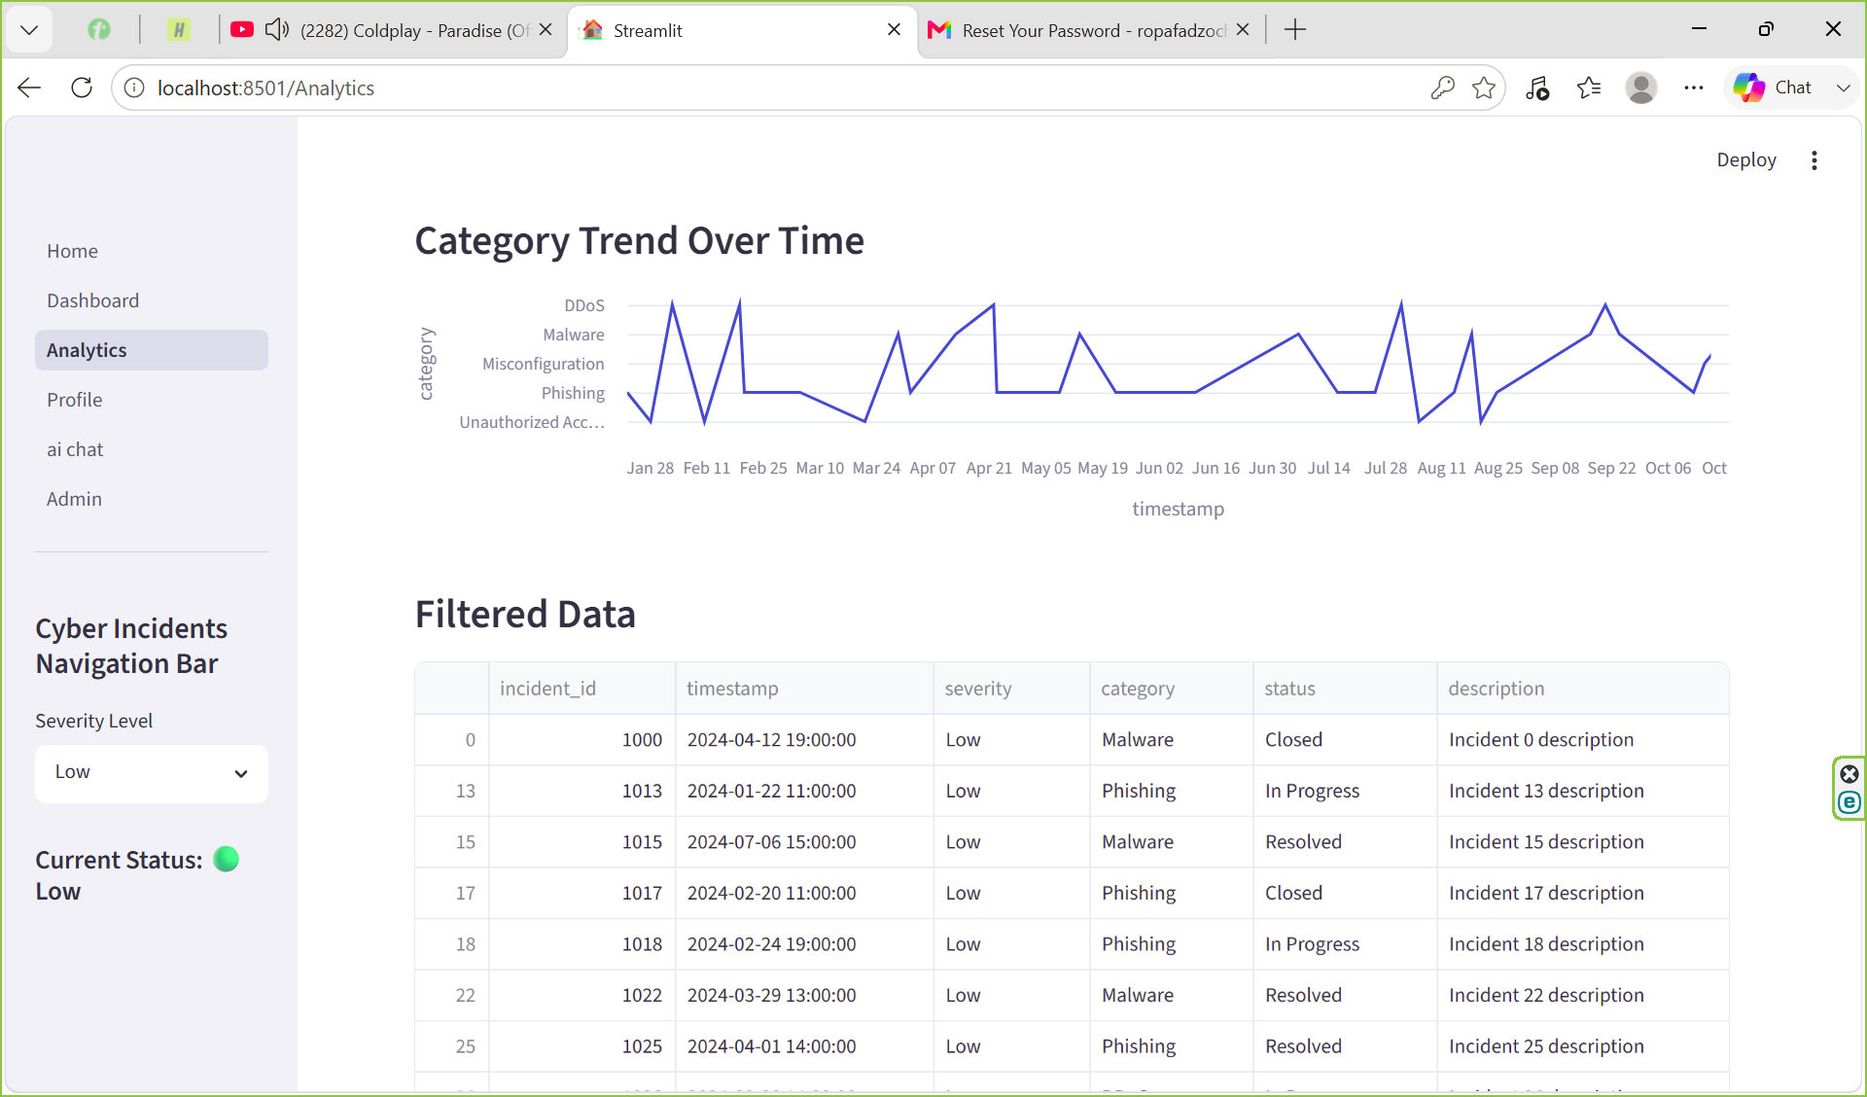
The cyber incidents are also visually illustrated using a line chart for the category over the time stamps when it was created which l made using the st.linechart function which is part of streamlit.The table is basically the raw upload of the filtered dataframe of cyber incidents.

3.3 Data Science Domain Dashboard
[Guidance: Screenshot: datasets table/metrics. Describe the dataset metadata displayed and any analysis shown.]
[Insert screenshot of your Data Science dashboard here]
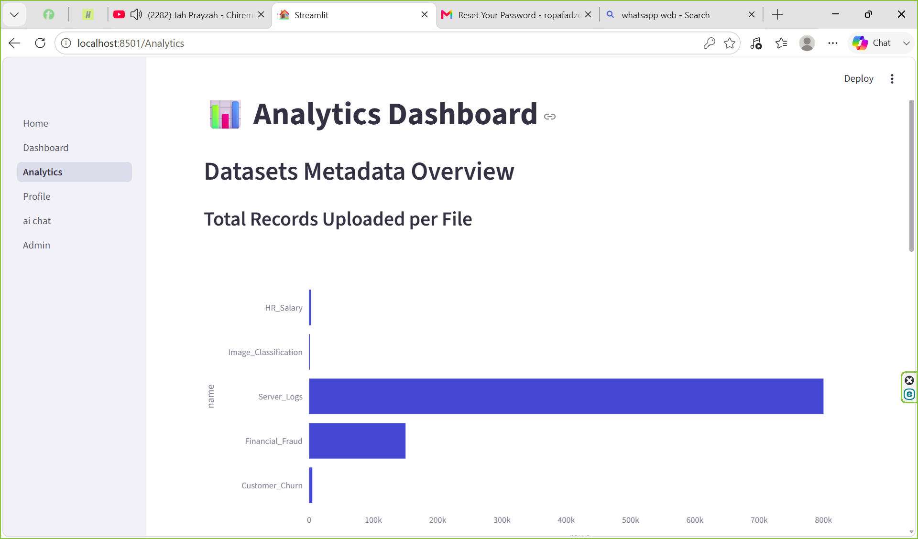
I implemented a bar chart using the plotly library to visualize the volume of records logged per category. This visualization provides a clear overview of system activity such as the server logs which currently show 800 000 records being actively monitored. This implementation allows users to quickly assess data scale and identify which categories are generating the highest volume of logs within the system.
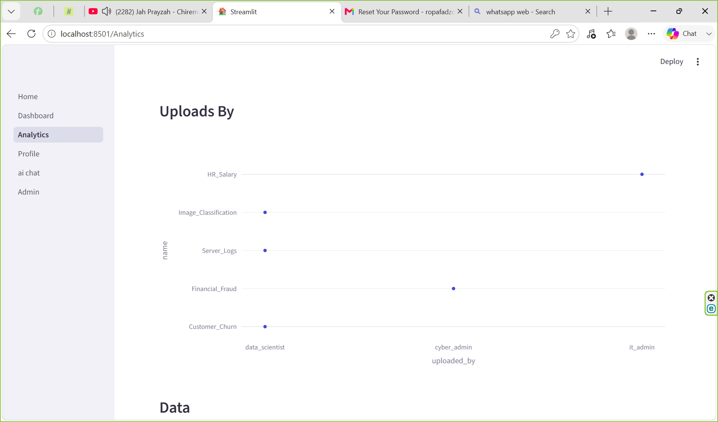
To supplement the existing analytics l also added a scatter plot implemented using the plotly library in which the scatter plot shows who uploaded the data for a specific category and we see that the data scientist did most of the uploads which are customer churn,server logs and image classification.
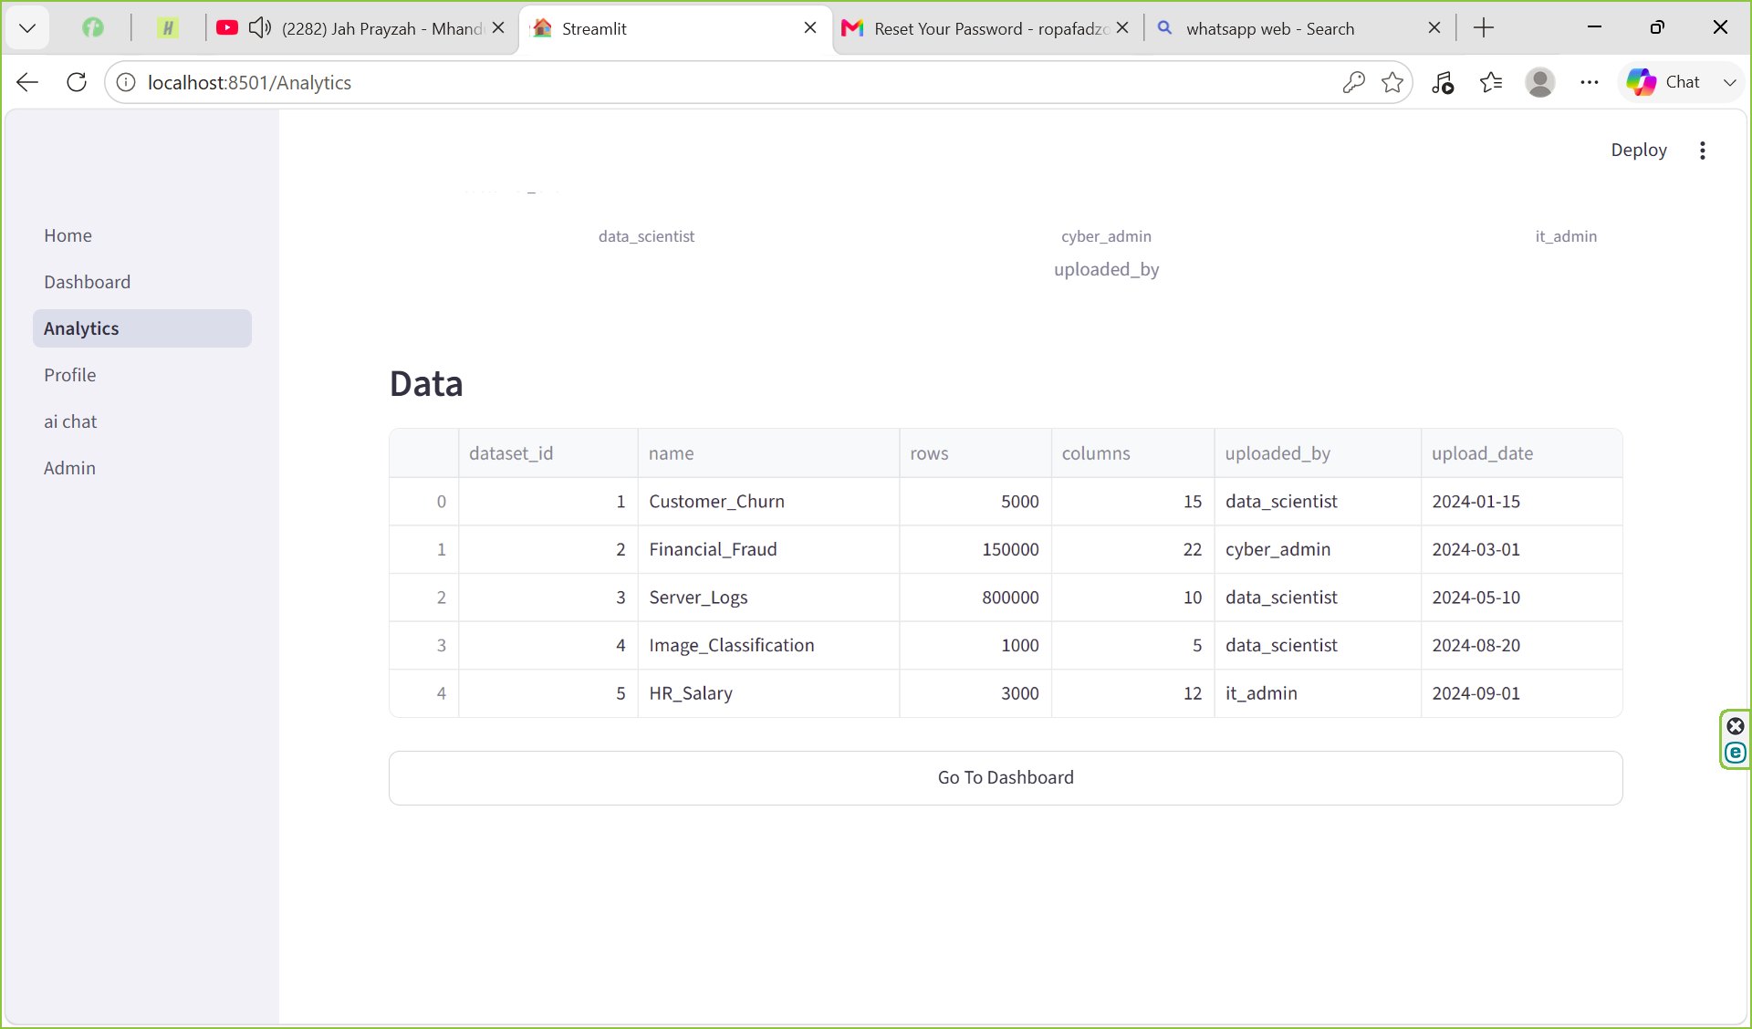
The last illustration being the table representing all the data from the metadata table in the database .

3.4 IT Operations Domain Dashboard
[Guidance: Screenshot: tickets table + priority chart. Describe ticket management features.]
[Insert screenshot of your IT Operations dashboard here]
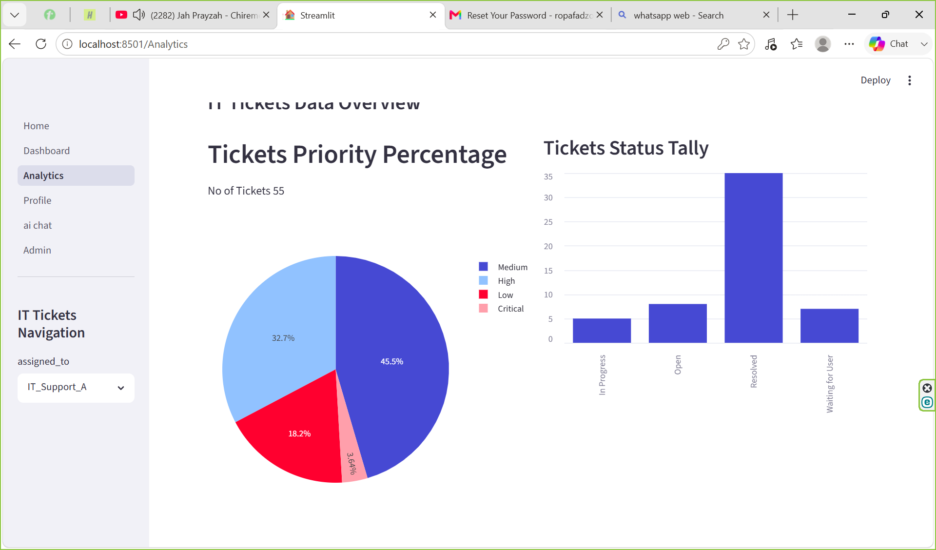
To visualize IT Tickets I implemented a pie chart that displays ticket distribution based on priority levels assigned to each IT support team. The visualization reveals a high volume of medium priority tickets providing immediate insight into IT Support A workload. Additionally I added a bar chart that displays a tally of tickets by status for example it tracks active status of tickets showing 5 tickets currently in progress and 7 tickets waiting for user input.
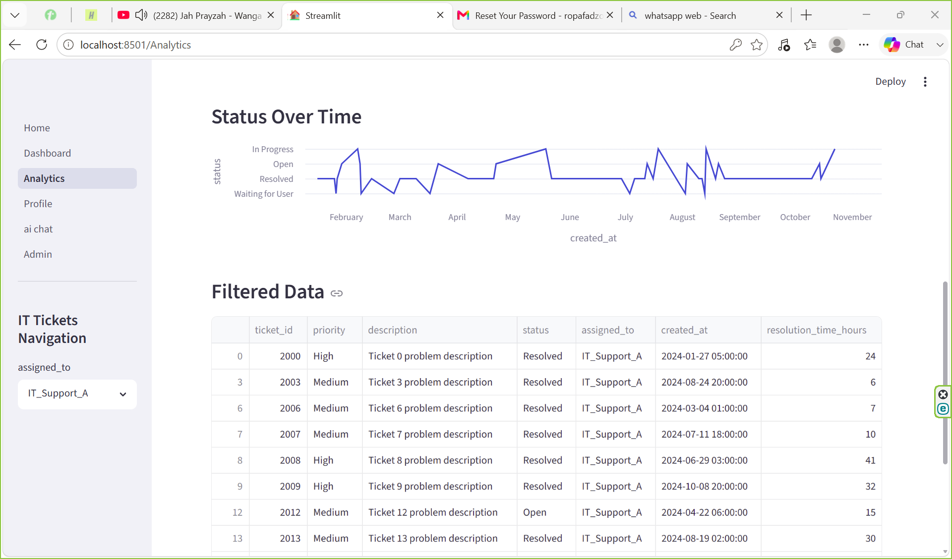
To supplement the existing analytics I implemented a line chart that tracks the distribution of IT ticket statuses over time offering a longitudinal view of team performance. For example, the chart highlights that in March ticket statuses were limited to "open," "waiting for user," and "resolved." Additionally I included a data table that outputs all raw information for tickets assigned to IT Support Team A providing a granular view for detailed operational auditing.

3.5 AI Assistant
[Guidance: Screenshot: chat interface in action. Show an example query and response. Describe which domain prompt you used and why the response demonstrates domain expertise.]
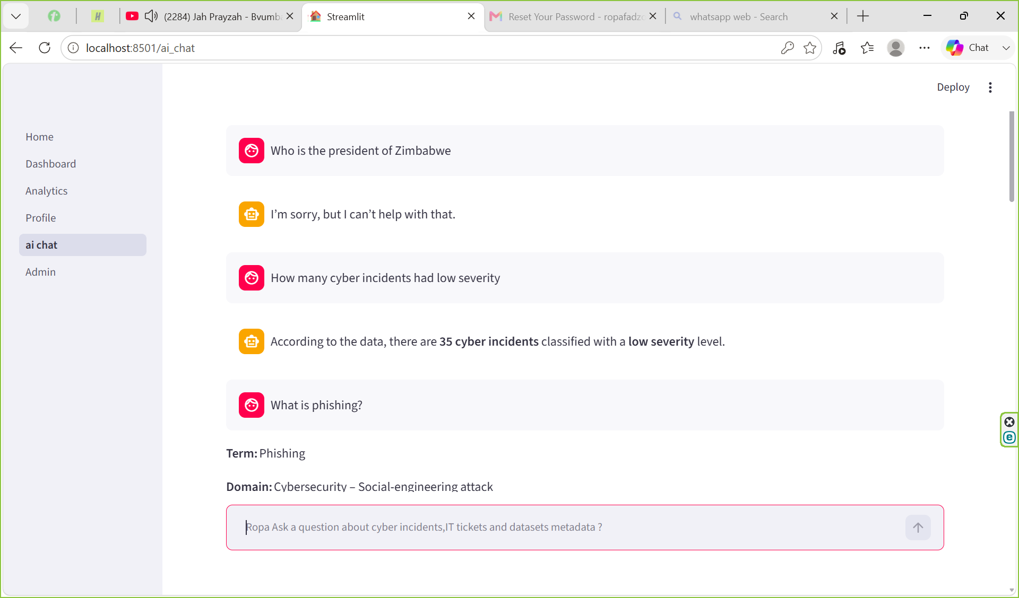
To provide more intelligent and secure user experience. I integrated a domain prompt for generating an SQL which could be injected into the database to return data to the specific user prompt. Which is shown on the screenshot where the user prompt is “how many cyber incidents had low severity” and the LLM provide the answer according to the data. It is also contextualized to return NO SQL NEEDED and it analyzes the prompt to see if it within the constraints of the domain expertise .This is demonstrated by the first question where it does not fit in the context its unable to answer but the last question it is able to answer it because it align with cybersecurity analyst knowledge and give a reply based of the terms and language of a cybersecurity analyst.

4. Testing & Validation
✎ Suggested word count: 150–300 words
[Guidance: Describe how you tested your application. Include a testing table showing what you tested, the expected result, and the actual result. Include at least 8 test cases covering authentication, CRUD, session state, and AI.]
FEATURE | TEST CASE DESCRIPTION | EXPECTED RESULT | ACTUAL RESULT
Authentication | Login with the correct credentials | Redirect to Home Dashboard | Successful
Authentication | Login with the incorrect credentials | Denied access and error message output displayed | Denied access and Error message
CRUD | Creating new user records upon registering | User information inserted into users table | Successful user was added
CRUD | Reading of table information in the database to display the information | Display of the tables on the Analytics dashboard and on the admin page | Successful everything was displayed
CRUD | Updating of user password and username and user email. | User information is expected to be updated on the user table so that when they login again they use new credentials | Successfully they managed to login again successfully with the new updated credentials
CRUD | Deleting of user account | When user tries to log in again without registering they are denied access | Successful due to denied access
Session State(Access) | Trying to gain access to other pages with the session state[“logged_in”] being False | Access denied and displaying of error message informing user to log in | Denied access if logged in session state is not true.
Session State(Access) | Trying to gain access to the Admin page when the session state[logged_in] is False and also the session state[“role]”} is not admin | Access is denied and error message is displayed | Denied access and error message shown
AI | Ask a question nonrelated to cyber security, it operations and data science. | Message displayed that it cannot answer the question | LLM successfully detected that the question was out of scope
AI | Ask a question related to it extracting information from the database. | Returning the specific information regarding the SQL and it is accurate. | Successful as it can actually return the correct information from the database tables.
AI | Ask a question within the constraints of cybersecurity, it operation and data science but no SQL needed | Answering the prompt using expertise knowledge in the area | Successful as it answer the question eloquently and correctly.

5. Reflection & Conclusion
✎ Suggested word count: 200–500 words

5.1 What I Learned
[Guidance: Reflect on the most valuable technical skills gained. Consider: bcrypt and security thinking, SQL and database design, Streamlit and web app development, API integration, and modular code architecture.]
Building this platform significantly deepened my understanding of the Model-View-Controller (MVC) architecture which streamlined navigation by organizing distinct functions into modular files rather than clustering code. As a cybersecurity student the most valuable takeaway was learning to prioritize system-wide security. Implementing bcrypt shifted my perspective toward designing for maximum protection rather than relying on basic authentication. This mindset drove me to further enhance security by enforcing regex requirements for passwords mandating a minimum of 8 characters including at least one digit, one lowercase letter, one uppercase letter, and one special character. Additionally working with Streamlit highlighted the vital role of temporary session states in ensuring application functionality.

5.2 Challenges Faced
[Guidance: Describe 2–3 specific technical problems. Be precise: what was the error or unexpected behaviour, what did you investigate, and how did you solve it?]
[Describe your first challenge here — e.g. database locking, session state not persisting, bcrypt encoding errors, API rate limiting, etc. Be specific about what went wrong and how you fixed it.]
A major technical challenge I encountered during development involved managing button and component interactions within Streamlit specifically regarding the importance of assigning unique keys. Initially I did not realize that Streamlit requires distinct keys for buttons which caused the application to malfunction because multiple buttons shared similar names without unique identifiers. I primarily encountered this issue on my profile page, where the frequent editing operations created conflicts in the user interface. Once I assigned unique keys to every button the application began running seamlessly resolving the conflicts and significantly improving the stability of the input forms.
[Describe your second challenge here.]
Another significant technical challenge I faced involved writing SQL commands for database execution. I discovered that database syntax is extremely sensitive to spelling and phrasing, which frequently causes queries to fail. I often spent considerable time troubleshooting errors that resulted from simple oversights such as omitting an 'S' in the IF EXISTS clause during table creation. These experiences underscored the importance of rigorous attention to detail and precise syntax when managing database structures.

5.3 Future Improvements
[Guidance: List 2–3 features or improvements you would add with more time. Be specific — not just 'better UI' but what exactly and why.]
Given additional development time, the following improvements would enhance the platform:
If I had more time to further develop the platform I would have pursued two primary enhancements. First, I would have created a "super admin" access level with higher privileges than the standard administrator allowing for advanced data manipulation such as adding new records or modifying existing information. Second, I would have focused on optimizing the overall website performance to reduce load times and ensure a more responsive and seamless user experience.

5.4 Conclusion
[Guidance: Summarise the project in 1–2 paragraphs. State what was built, whether the requirements were met, and what the most important outcome was.]
The development of this multi domain platform which facilitates the display of cyber incidents, IT tickets and dataset metadata. It integrates secure user authentication and also a contextualized LLM. Overally l think it was a success all project requirements were met with the system operating reliably and performing its intended functions while also including additional value-added features.

6. References
[Guidance: List all sources cited or consulted. Use a consistent academic referencing style (Harvard recommended). Include library documentation, any books, and academic papers consulted.]
A Beginners Guide To Streamlit(2026)Available at: A Beginners Guide To Streamlit - GeeksforGeeks (Accessed: 28 June 2026).
Password validation in Python (2025) Available at: Password validation in Python -GeeksforGeeks (Accessed: 1 July 2026).
Python Database Tutorial(2025)Available at:smtplib — SMTP protocol client — Python 3.14.6 documentation(Accessed: 25 June 2026).
smtplib — SMTP protocol client(2026)Available at:smtplib — SMTP protocol client — Python 3.14.6 documentation(Accessed: 8 July 2026).
st.query_params (2026) Available at: st.query_params - Streamlit Docs (Accessed: 10 July 2026).

